**Question 1**

1. Create a blank file named "myfile"

2. Open "myfile" in vi editor

3. Write your name, address, email id, phone number and blood group in 5 different lines

4. Build one single expression to see the line with your name and blood group in myfile

**Step 1:** Create a blank file named "myfile"

**Screenshot 1:**

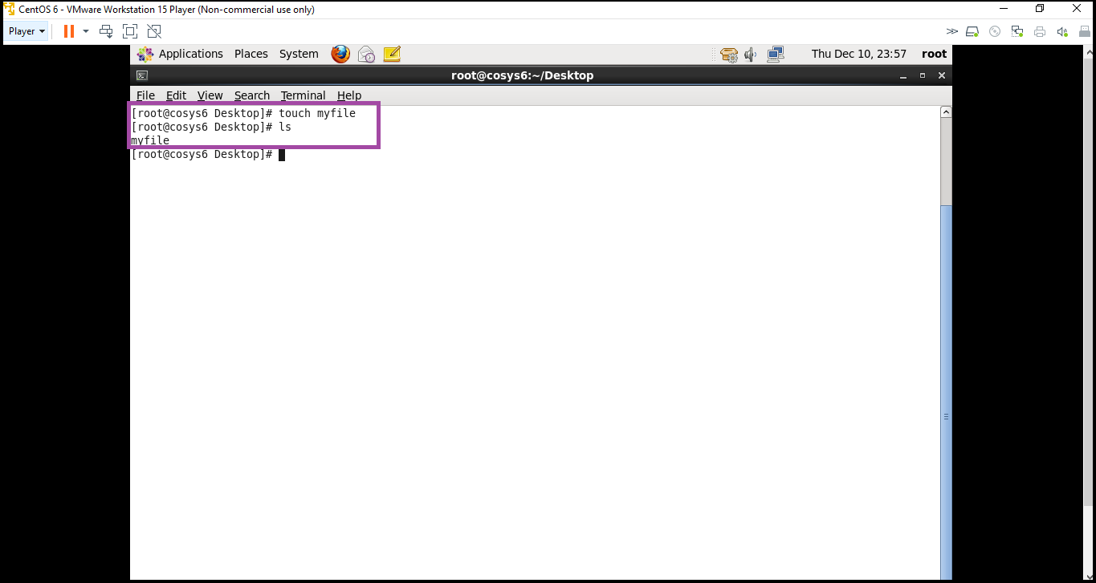

**Step 2:** Open "myfile" in vi editor

**Screenshot 1:**

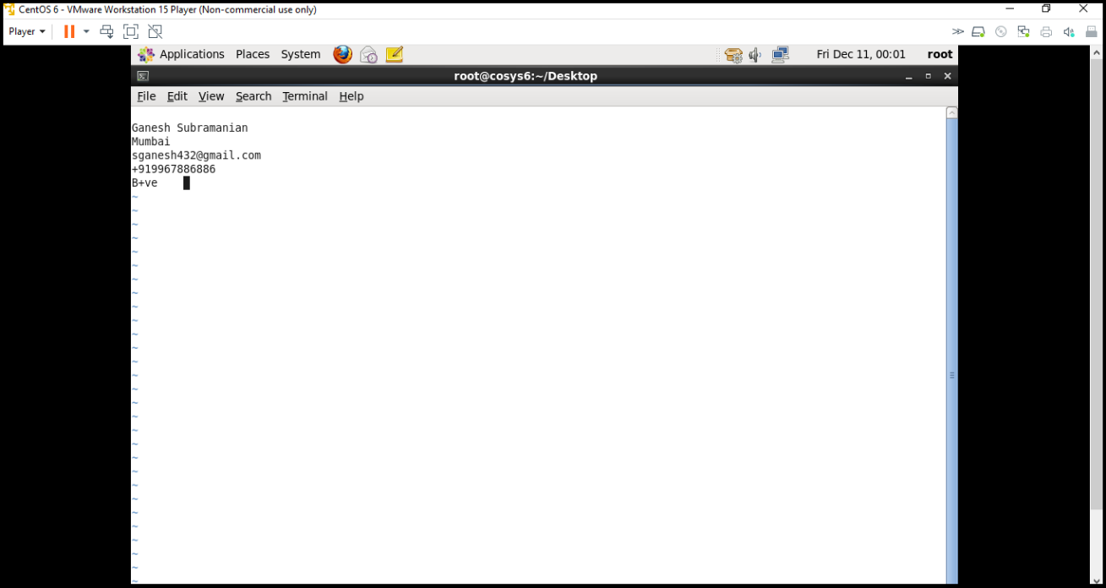

**Step 3:** Write your name, address, email id, phone number and blood group in 5 different lines

**Screenshot 1:**

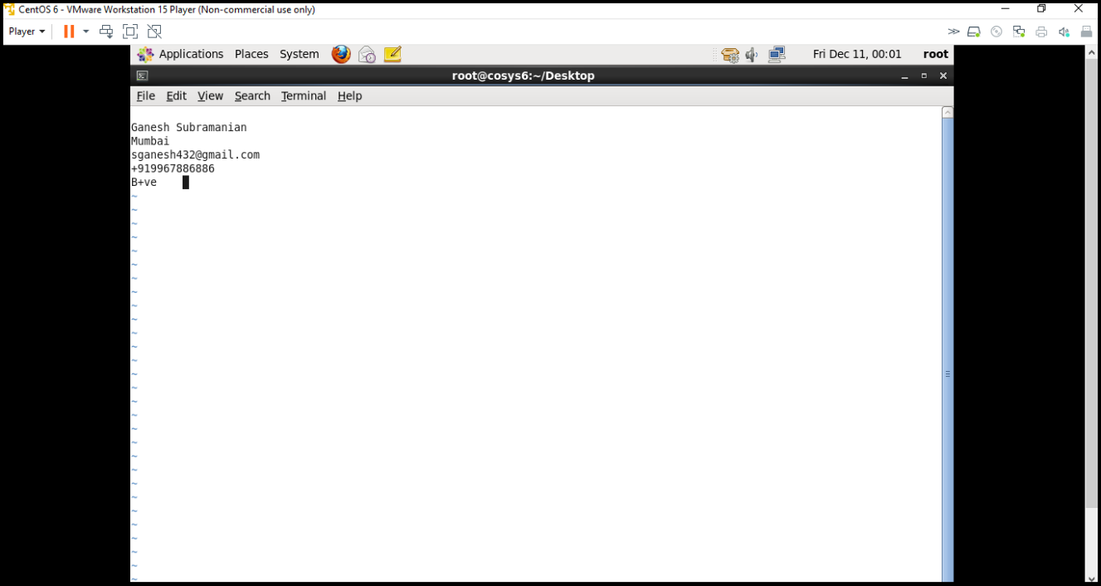

**Step 4:** Build one single expression to see the line with your name and blood group in myfile

**Screenshot 1:**

